**How to Install WAMP on Windows**

Below are the detailed steps on how to install WAMP that you need to follow for a successful WAMP installation.

**Follow these steps to install WAMP**

**Step 1: Download the WAMP Server**

Go to the official website <https://www.wampserver.com/en/> and download the WampServer setup. There are two versions of WampServer are available i.e. 64-bits (x64) and 32-bits (x86), choose according to your computer’s configuration.

As soon as you will click on the download option, a pop up will appear showing some warnings. Just don’t worry about these warning rather simply click on the link “download directly” like shown below and move ahead with the download process.

**Step 2: Initiate WAMP Server Install Process**

Soon after you click on the downloaded file, you will be asked to choose your preferred language and click the “Ok” button. As I’m choosing English here. See below.

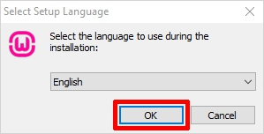

The next screen you will see is about the license agreement. Click on the “I accept the agreement” radio button and then the “Next” button to continue with the installation shown below.

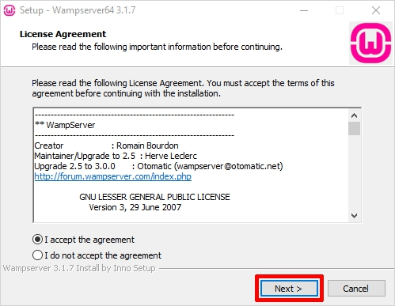

The next screen will inform you about the required components that have to be present in your computer system for the proper functioning of the WampServer. The main purpose of this step is to check for the suitable version of Microsoft VC++ re-distributable package. Click on the ‘Next’ to continue.

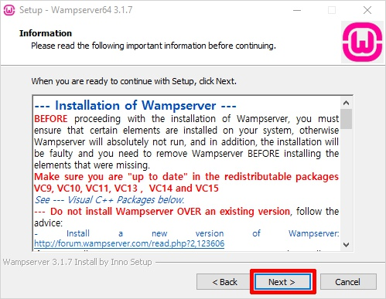

**Step 3: Select Location/Destination to Install WAMP**

Here, you need to select the location to install the WAMP on your computer. However, you can accept the default location and move ahead. To continue with the installation hit the ‘Next’ button.

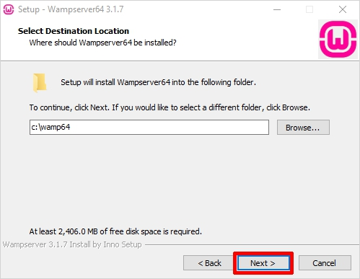

**Step 4: Select Start Menu Folder to Install WAMP**

Now, you need to select the folder where you wish to create the program’s shortcut. You can select any folder of your choice or you can continue with the default option. You can easily access this folder from the Windows start button. Choose the folder and click ‘Next’ to continue.

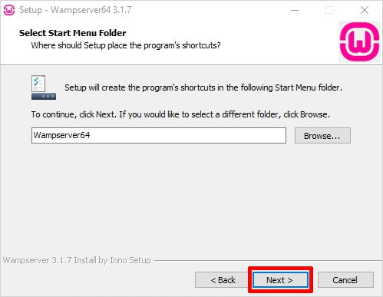

**Step 5: Ready to Install WAMP**

Finally, you would see a ready to install wizard with a ready setup to begin the installation. Just hit the ‘Install’ button to begin the installation procedure.

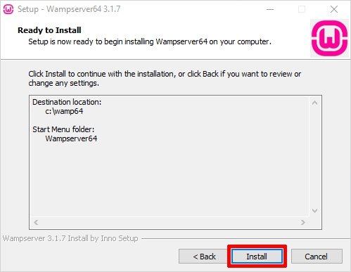

Now, just be patient as the WampServer is extracting files to your selected location. Let the process complete.

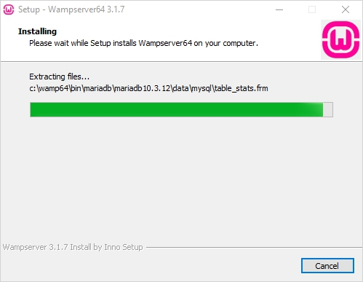

Once the status bar is turned fully green, an information screen will appear like the one shown below. Click ‘Next’ to continue.

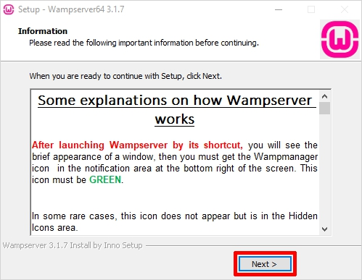

**Step 6: WAMP Installation Complete**

The installation is almost done now simply click ‘Finish’ to exit the setup.

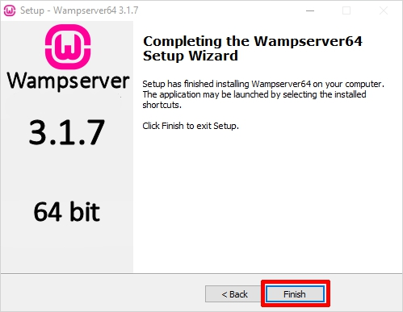

That’s all. You are ready with the WAMP server now. So, enjoy WAMPing!!